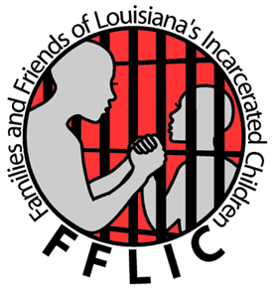Registration Form
FFLIC 5K Run/Walk for Juvenile Justice

Sunday, October 7, 2012 | Audubon Park, Shelter #10
Registration begins at 8:00 am – Race begins at 9:30 am

Registration Fees:
- Children (17 & Under): $15
- Adults: $20
- Groups of 5: $15 each

Name _____________________________________________ Age_________ Gender ____
Address ____________________________________________________________________
City _______________________________________________________ State____________
Zip ________________________ Phone (_____) ___________________________________
E-mail address_______________________________________________________________

T-Shirt Size: Adult S ( ) M ( ) L ( ) XL ( ) XXL ( )

Cash or Check
Total enclosed $_____________
Credit Card_______________________________________
Name on Card___________________________ Card Type MC_____Visa______ AMEX______
Account Number _______________________________________Ex date ________ CVV______
Signature of Card Holder:________________________________________ Date_____________

Waiver: In consideration of foregoing, I myself, executors, administrators, and assigns, do hereby discharge the personnel of Audubon Park, Families and Friends of Louisiana’s Incarcerated Children, and all sponsors and their representatives and successors from all claims of damage, actions, and causes whatsoever, in any matter arising or growing out of my participation.

Signature _____________________________________________ Date_________________
(Parent or guardian signature for participants under the age of 18)

